

DIVISION OF COMPUTER SCIENCE AND ENGINEERING SCHOOL OF COMPUTER SCIENCE AND TECHNOLOGY

A PROJECT BASED EVALUATION REPORT

SUBMITTED BY

ASHIC PAUL P S (URK23CS1021)

COURSE CODE 23CS2019

COURSE NAME
DISTRIBUTED COMPUTING

APRIL 2026

DISTRIBUTED MEDICINE REMINDER SYSTEM

A PROJECT REPORT

Submitted by

ASHIC PAUL PS (URK23CS1021) MAHA DEEPAK S (URK23CS1220) ALDAN JOSEPH S (URK23CS1216)



DIVISION OF COMPUTER SCIENCE AND ENGINEERING

KARUNYA INSTITUTE OF TECHNOLOGY AND SCIENCES

(Declared as Deemed-to-be-under Sec-3 of the UGC Act, 1956) Karunya Nagar, Coimbatore - 641 114. INDIA

APRIL 2026

AZURE CERTIFICATE


AWS CERTIFICATE

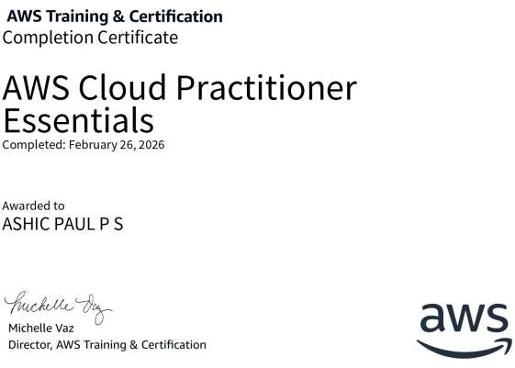

ABSTRACT

The Distributed Medicine Reminder & Adherence Tracking System is a healthcare-oriented distributed application designed to address the critical issue of medication non-adherence among patients. Missing or incorrectly taking prescribed medicines can lead to severe health complications, especially for elderly individuals and patients with chronic conditions. This project aims to provide an efficient, scalable, and automated solution to ensure timely medication intake through a combination of real-time interaction and background processing.
The system is built using a distributed client-server architecture, where multiple components operate independently while coordinating through well-defined interfaces. The frontend, developed using Flutter, provides a user-friendly interface that allows users to register, log in, add medicines, define dosage and schedules, and track their medication history. The backend, implemented using Node.js and Express, handles authentication, request processing, and business logic. MongoDB is used as the database to store user information, medicine schedules, and adherence logs.
A key feature of the system is the background reminder service, implemented using a cron-based scheduler. This service runs as an independent process, continuously monitoring scheduled medicine timings without requiring user interaction. It automatically generates logs indicating whether a medicine is pending, taken, or missed. This separation of concerns demonstrates real-world distributed system behavior, where different components operate asynchronously while maintaining coordination through a shared database.
The system incorporates several important distributed computing concepts such as stateless REST communication, asynchronous processing, process coordination, eventual consistency, and fault tolerance. The loose coupling between components ensures scalability and flexibility, allowing the system to handle multiple users efficiently.
The results of the system show improved medication adherence through timely reminders and accurate tracking. The system reduces dependency on manual methods and provides a reliable mechanism for monitoring patient behavior. It can be effectively used by patients, caretakers, and healthcare providers for better health management.
In conclusion, the proposed system successfully demonstrates the design and implementation of a distributed application in the healthcare domain. It highlights how distributed components can work together to solve real-world problems while ensuring reliability, scalability, and efficiency. Future enhancements may include real-time push notifications, cloud deployment, integration with wearable devices, and AI-based prediction of medication adherence patterns.

INDEX

- Introduction
  - Background / Motivation

  - Problem Statement

  - Scope of the Project

  - Applications

  - Organization of the Report

- Design and Methodology
  - Proposed System

  - Design Considerations

  - Evaluation Framework

- Implementation
  - Tools and Technologies Used

  - System Workflow and Execution

  - Key Implementation Features
- Result Analysis
  - Results Presentation

  - Performance Evaluation

  - Result Interpretation

  - Comparative Analysis

- Conclusion
  - Summary of the Project

  - Achievements and Limitations
  - Future Enhancements and Recommendations References
Appendices

CHAPTER 1 INTRODUCTION
  - Background / Motivation
In today’s fast-paced lifestyle, many individuals tend to forget to take their prescribed medicines on time. This issue is especially critical for elderly patients, individuals with chronic diseases, and those undergoing long-term treatments. Missing doses or taking medicines at incorrect times can lead to serious health complications, reduced treatment effectiveness, and in some cases, life-threatening conditions. Traditional methods such as manual reminders, alarms, or written schedules are often unreliable and dependent on human memory and consistency.
With the advancement of technology, there is a growing need for an automated and intelligent system that can assist users in managing their medication schedules efficiently. A system that provides timely reminders, tracks adherence, and maintains a history of medicine intake can significantly improve patient outcomes. Additionally, real-time tracking of medication status allows users and caretakers to monitor adherence more effectively.
Therefore, this project is motivated by the need to develop a distributed, automated solution that ensures users do not miss their medications while providing accurate tracking and monitoring capabilities. By integrating background processing and real-time interaction, the system aims to enhance reliability, reduce human error, and improve overall healthcare management.

  - Problem Statement
Medication non-adherence is a significant challenge in healthcare, where patients often forget to take medicines on time or fail to follow prescribed schedules accurately. Existing solutions such as manual reminders, alarms, or basic mobile applications lack proper tracking, automation, and reliability, leading to missed doses and inconsistent medication intake. This problem is more critical for elderly individuals, patients with chronic illnesses, and those requiring strict medication routines.
There is a need for a robust and scalable system that not only reminds users about their medicines but also tracks adherence, maintains historical records, and operates independently of continuous user interaction. The system must be capable of handling multiple users, managing dynamic schedules, and ensuring accurate and timely updates of medication status.
To address these challenges, the problem is defined as the design and implementation of a distributed medicine reminder and adherence tracking system that utilizes a client-server architecture, asynchronous background processing, and coordinated data management. The system should ensure reliable reminder generation, maintain consistency of data across components, and provide fault tolerance through independent service execution. The ultimate goal is to minimize missed medications, improve adherence, and provide an efficient healthcare support system.

  - Scope of the Project
• Covers scheduling, reminders, tracking
• Does NOT include medical diagnosis
• Works for patients & caretakers

  - Applications
Personal healthcare
Hospitals
Elderly care systems
Remote patient monitoring

  - Organization of the Report

● The Abstract provides a concise summary outlining the objectives, scope, key features, and overall purpose of the Distributed Medicine Reminder & Adherence Tracking System.
● Chapter 1 presents the Introduction, including the background, motivation, problem statement, scope of the project, applications, and organization of the report.
● Chapter 2 describes the Design and Methodology, detailing the distributed system architecture, system components, workflow, design considerations, and evaluation framework.
● Chapter 3 focuses on Implementation, explaining the tools and technologies used, system workflow, background reminder service, and execution process of the application.
● Chapter 4 presents Result Analysis, including system outputs, performance evaluation, reliability of the reminder service, and comparative analysis with existing methods such as manual reminders and basic applications.
● Chapter 5 concludes the report with a summary of the project, achievements, limitations, and future enhancements for improving the system.
● The References section lists all resources, documentation, and technologies referred to during the development of the project.
● The Appendices section includes supplementary materials such as code snippets, system configurations, sample data, and testing results.

CHAPTER 2
DESIGN AND METHODOLOGY
  - Proposed System
The proposed system follows a distributed client-server architecture consisting of multiple independent components that communicate through REST APIs. The system is divided into four major layers: the client layer, API layer, data layer, and background service layer.
The client layer is implemented using a Flutter-based application, which provides a user-friendly interface for registration, login, medicine scheduling, and adherence tracking. Users interact with the system through this interface to manage their medication details.
The API layer is developed using Node.js and Express, which acts as the central controller of the system. It handles user authentication, processes client requests, manages business logic, and communicates with the database. All communication between the frontend and backend is performed using stateless REST APIs over HTTP.
The data layer uses MongoDB as the database to store user information, medicine schedules, and adherence logs. This centralized database acts as the shared medium through which different system components coordinate and exchange information.
A key component of the system is the background reminder service, implemented using a cron-based scheduler (Node-cron). This service runs as an independent process and continuously monitors medicine schedules stored in the database. It automatically updates the status of medicines as pending, taken, or missed without requiring direct user interaction.
The workflow of the system is as follows:
- The user registers and logs into the system through the frontend.
- The user adds medicine details including dosage, timing, and frequency.
- The backend stores this information in the database.
- The background service periodically checks the database for scheduled medicines.
- Based on timing conditions, the system generates reminder logs (pending, missed).
- The user can update the status as “taken,” which is recorded in the database.
- The updated information is reflected in the dashboard for tracking and analysis.
This architecture demonstrates distributed system principles such as asynchronous processing, loose coupling, independent service execution, and coordination through a shared database.

  - Design Considerations
The system is designed by considering several important factors to ensure efficiency, scalability, and reliability.
Scalability:
The system is designed to support multiple users simultaneously. The use of a distributed architecture allows components to scale independently based on demand.
Loose Coupling:
Each component of the system (frontend, backend, database, background service) operates independently, reducing dependencies and making the system easier to maintain and extend.
Fault Tolerance:
The background reminder service runs independently of the user interface. Even if the frontend is inactive, the system continues to monitor and update medicine schedules, ensuring reliability.
Asynchronous Processing:
The use of a cron-based background service allows tasks to be executed asynchronously without blocking user interactions.
Data Consistency:
All components interact with a centralized database, ensuring that updated information is consistently reflected across the system.
Real-Time Tracking:
The system provides near real-time updates of medicine status, enabling users to track adherence effectively.
Security Considerations:
Basic authentication mechanisms are implemented to protect user data and ensure secure access to the system.

  - Evaluation Framework

The performance and effectiveness of the system are evaluated based on the following parameters:
Accuracy of Reminder Generation:
The system is evaluated on its ability to correctly generate reminders based on the scheduled time of medicines.
System Response Time:
The time taken for the backend to process requests and return responses to the client is measured to ensure efficiency.
Reliability of Background Service:
The cron-based reminder service is tested for continuous execution and correct handling of scheduled tasks without failure.
Data Consistency:
The system is evaluated to ensure that updates made by different components are accurately reflected in the database.
Scalability:
The system is tested with multiple users to ensure it can handle increased load without performance degradation.
User Experience:
The ease of use, clarity of dashboard, and effectiveness of tracking features are considered for evaluation.

CHAPTER 3 IMPLEMENTATION
  - Tools and Technologies Used
The implementation of the Distributed Medicine Reminder & Adherence Tracking System is carried out using modern technologies that support scalability, flexibility, and efficient communication between distributed components.
Frontend (Client Layer):
The user interface is developed using Flutter, which enables cross-platform application development for web and mobile. It provides a responsive and user-friendly interface for managing medicine schedules and tracking adherence.
Backend (API Layer):
The backend is implemented using Node.js with the Express.js framework, which handles API requests, authentication, and business logic. It acts as the intermediary between the frontend and the database.
Database (Data Layer):
The system uses MongoDB, a NoSQL database, to store user data, medicine schedules, and adherence logs. Its flexible schema design allows efficient handling of dynamic data.
Scheduler (Background Service):
The background reminder system is implemented using Node-cron, which schedules periodic tasks to monitor medicine timings and update their status.
API Communication:
Communication between frontend and backend is achieved using REST APIs over HTTP, ensuring stateless interaction and loose coupling between components.
Development Tools:
- Visual Studio Code (IDE)
- Postman (API testing)
- Git (version control)

  - System Workflow and Execution
The system operates through a sequence of coordinated steps involving user interaction, backend processing, and background execution.
- The user registers and logs into the system using the Flutter-based frontend.
- The user adds medicine details such as name, dosage, frequency, and timing.
- The frontend sends this data to the backend through REST API requests.
- The backend processes the request and stores the information in the MongoDB database.
- The background reminder service continuously runs as a scheduled process using Node-cron.
- The service periodically checks the database for upcoming or overdue medicine schedules.
- Based on the timing conditions, the system updates the status of each medicine as:
  - Pending (upcoming)
  - Taken (marked by user)
  - Missed (not taken within time)
- The user can manually update the status of medicines as “taken,” which is stored in the database.
- The updated data is reflected in the dashboard, allowing users to monitor their medication history and adherence.
This workflow ensures smooth coordination between system components and demonstrates asynchronous execution and distributed processing.

  - Key Implementation Features

The system includes several important features that highlight its distributed nature and practical usability:
Independent Background Reminder Service:
The cron-based scheduler operates as a separate process, ensuring that reminders and status updates are generated even when the user is inactive.
Automated Status Tracking:
The system automatically classifies medicines as pending, taken, or missed based on timing and user actions.
Stateless API Communication:
The use of REST APIs ensures that each request is independent, improving scalability and reliability.
Centralized Data Management:
All components interact with a shared MongoDB database, enabling coordination and consistency across the system.
User-Friendly Interface:
The Flutter-based frontend provides a clean and intuitive dashboard for easy navigation and tracking.
Asynchronous Processing:
Background tasks run independently of user requests, ensuring non-blocking execution and improved performance.
Scalability and Flexibility:
The system design allows easy extension to support additional features such as notifications, cloud deployment, and integration with healthcare systems.

CHAPTER 4 RESULT ANALYSIS

  - Results Presentation
The system was successfully implemented and tested using multiple user scenarios to validate its functionality. The application allows users to register, log in, add medicines, and monitor their medication schedules through a centralized dashboard.
The results of the system include:
- Successful storage of user and medicine data in the MongoDB database
- Accurate scheduling and retrieval of medicine timings
- Automatic generation of medicine status logs such as pending, taken, and missed
- Real-time updating of medicine status when users mark medicines as taken
- Display of adherence history in a structured and user-friendly dashboard
The background reminder service was observed to run continuously and correctly update medicine statuses based on time conditions. The frontend interface reflected these updates dynamically, ensuring that users could easily track their medication adherence.

  - Performance Evaluation
The performance of the system was evaluated based on several important parameters:
Response Time:
The backend API demonstrated fast response times for user requests such as adding medicines and updating statuses, ensuring smooth interaction.
Reminder Accuracy:
The cron-based scheduler accurately generated reminders and updated medicine statuses according to the predefined schedule.
Reliability:
The background service operated continuously without interruption, ensuring that medicine tracking was maintained even when users were inactive.
Scalability:
The system handled multiple users and medicine schedules efficiently without noticeable performance degradation.
Consistency:
Data updates made by different components were accurately reflected in the database, maintaining consistency across the system.

  - Result Interpretation
The results indicate that the system effectively addresses the problem of medication non-adherence by providing automated reminders and accurate tracking. The independent background service ensures that reminders are generated reliably without relying on user interaction.
The system significantly reduces the chances of missed medicines by continuously monitoring schedules and updating statuses. Users are able to track their medication history clearly, which improves awareness and adherence.
The distributed architecture contributes to better performance, as tasks are divided among different components. This separation of concerns improves system efficiency, maintainability, and reliability.

  - Comparative Analysis

The proposed system was compared with traditional and existing methods of managing medicine schedules:
Manual Methods (Written Notes):
- Prone to human error
- No automation
- No tracking mechanism
Basic Alarm/Reminder Apps:
- Provide reminders but lack adherence tracking
- No centralized data storage
- Limited automation
Proposed System:
- Automated reminder generation
- Real-time adherence tracking
- Centralized database management
- Independent background processing
- Scalable and distributed architecture
The comparison clearly shows that the proposed system offers a more advanced and reliable solution by combining automation, tracking, and distributed system capabilities.

CHAPTER 5 CONCLUSION
  - Summary of the Project
The Distributed Medicine Reminder & Adherence Tracking System was developed to address the problem of medication non-adherence by providing an automated and reliable solution. The system enables users to manage their medicine schedules, receive timely reminders, and track their adherence history through a centralized dashboard.
The project successfully implements a distributed architecture consisting of a Flutter-based frontend, a Node.js and Express backend, a MongoDB database, and a cron-based background reminder service. These components work together through REST APIs to ensure smooth communication and coordination.
The system demonstrates key distributed computing concepts such as asynchronous processing, stateless communication, process coordination, and fault tolerance. By integrating real-time user interaction with automated background processing, the project provides an efficient and scalable solution for healthcare management.

  - Achievements and Limitations

Achievements
- Successfully designed and implemented a distributed system for medicine management
- Automated reminder generation using a background cron-based service
- Accurate tracking of medicine status (pending, taken, missed)
- Efficient coordination between frontend, backend, and database
- Implementation of REST-based communication ensuring scalability
- User-friendly interface for easy interaction and monitoring
- Demonstration of key distributed system concepts in a real-world application

Limitations
- The system currently relies on server uptime for background service execution
- Real-time push notifications (SMS/Email) are not implemented
- Limited to basic authentication without advanced security mechanisms
- Does not include integration with healthcare providers or wearable devices
- Performance testing is limited to a small-scale environment

  - Future Enhancements and Recommendations

The system can be further improved by incorporating additional features and enhancements:
- Implementation of real-time notifications using SMS, email, or push notifications
- Deployment on cloud platforms to improve availability and scalability
- Integration with wearable devices and IoT-based health monitoring systems
- Addition of AI-based prediction to analyze user behavior and improve adherence
- Advanced security mechanisms such as encryption and multi-factor authentication
- Support for caretaker and doctor dashboards for remote monitoring
- Development of a mobile-native application for better accessibility

REFERENCES
- Node.js Documentation. Available at: https://nodejs.org/en/docs
- Express.js Documentation. Available at: https://expressjs.com/
- MongoDB Documentation. Available at: https://www.mongodb.com/docs/
- Flutter Documentation. Available at: https://docs.flutter.dev/
- Node-cron Documentation. Available at: https://www.npmjs.com/package/node-cron
- REST API Design Principles. Available at: https://restfulapi.net/
- Andrew S. Tanenbaum, Maarten Van Steen, Distributed Systems: Principles and Paradigms, Pearson Education
- George Coulouris, Jean Dollimore, Tim Kindberg, Gordon Blair, Distributed Systems: Concepts and Design, Pearson
- MDN Web Docs – HTTP Overview. Available at: https://developer.mozilla.org/en-US/docs/Web/HTTP
- Git Documentation. Available at: https://git-scm.com/docs

APPENDICES

Appendix A: Sample API Endpoints
- POST /register – User registration
- POST /login – User authentication
- POST /medicines – Add new medicine
- GET /medicines – Retrieve all medicines
- PUT /medicines/:id – Update medicine details
- PUT /medicines/:id/status – Mark medicine as taken

Appendix B: Sample Medicine Data (MongoDB Document)

{
"userId": "12345",
"medicineName": "Paracetamol",
"dosage": "500mg",
"frequency": "Twice a day",
"timing": "08:00 AM, 08:00 PM",
"status": "Pending"
}

Appendix C: Cron Job Example

cron.schedule('* * * * *', () => {
// Check medicine schedules
// Update status (pending/missed)
});

Appendix D: System Screenshots

Login Page

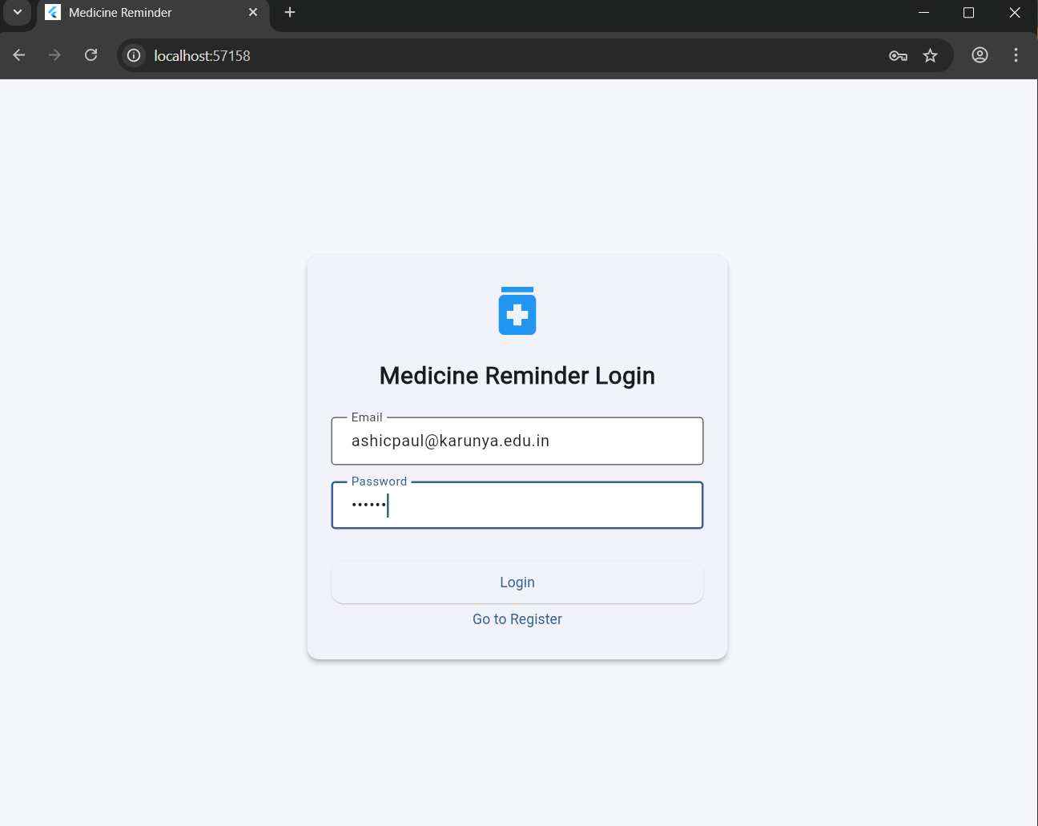

Dashboard

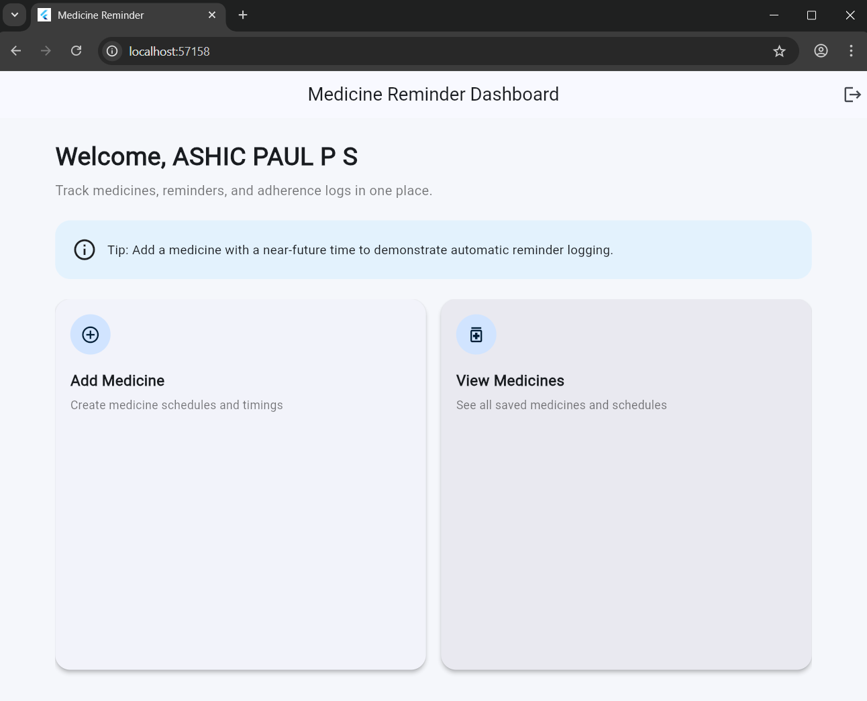

Add Medicine Screen

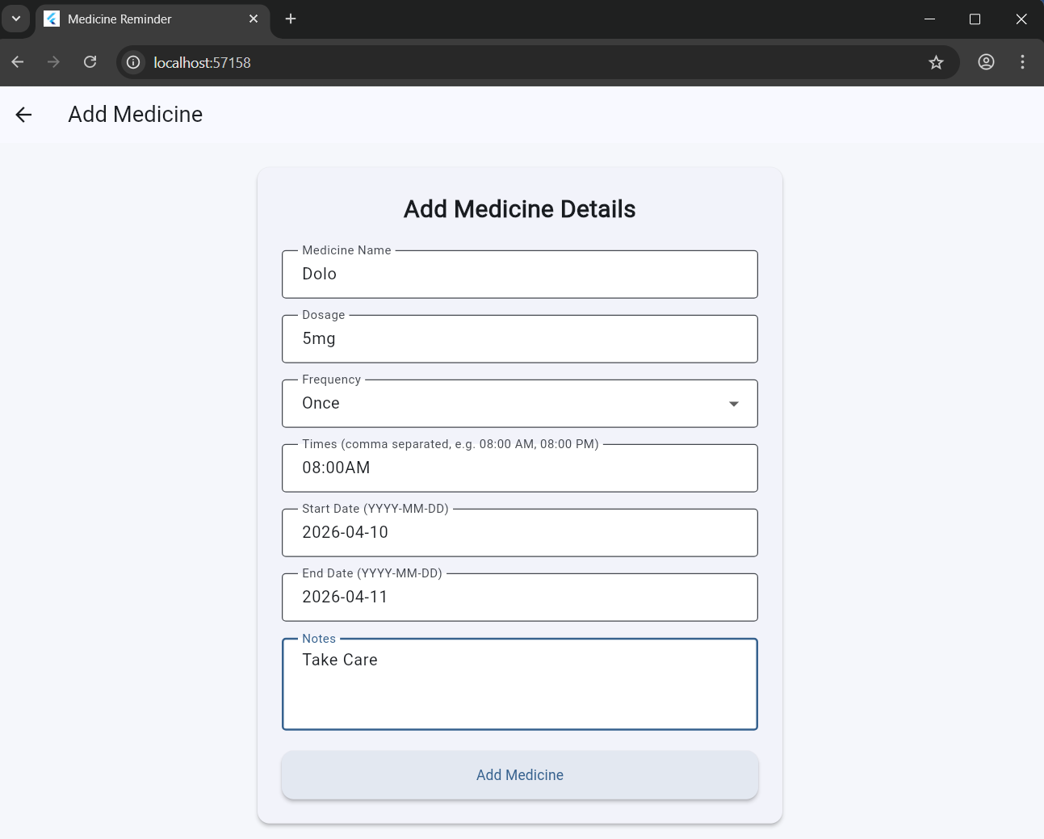

Medicine History

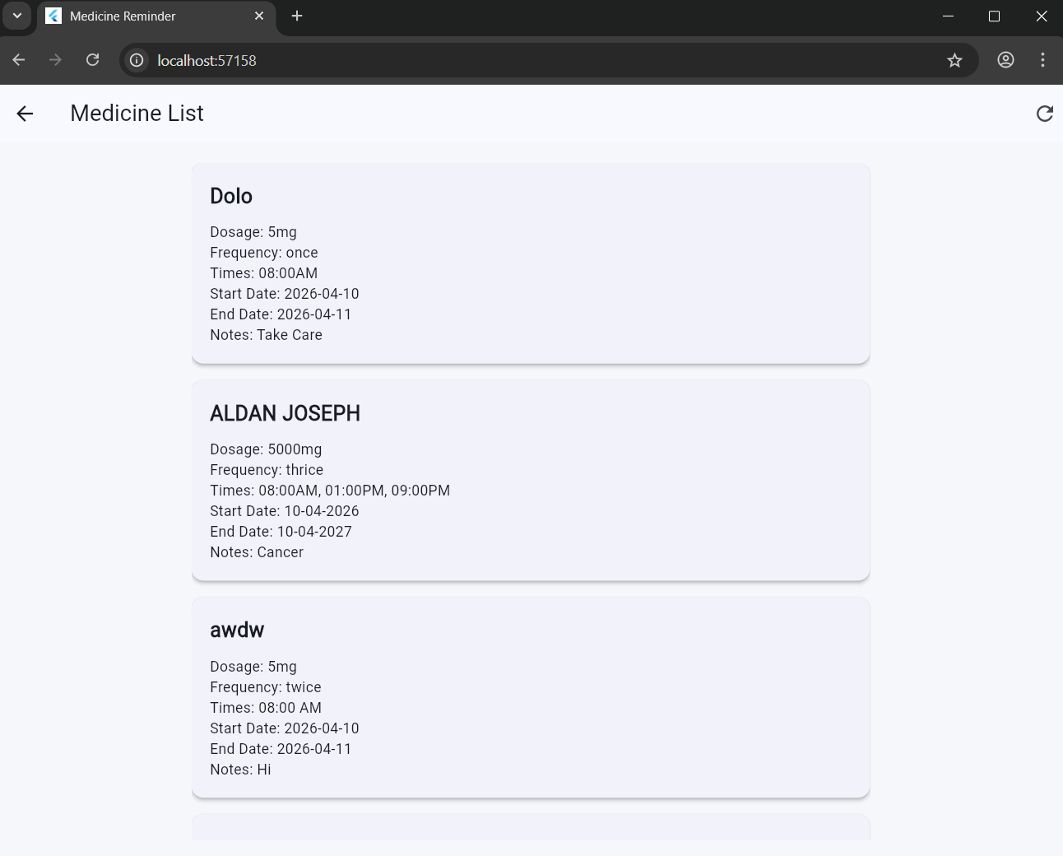


Rubrics for Skill Based Evaluation
Course Name: Distributed Computing
Course Code: 23CS2019 Class: B.Tech. CSE Semester: VI
Course Instructors:
    - Dr. A. Samson Arun Raj
    - Mrs. Denisha
    - Mrs. Sneha George
    - Mr. Rishab Haldar
Course Coordinator:
- Dr. C. P. Shirley

- Project Evaluation – 20 Marks
The students are expected to develop a project to exhibit their skills on the course content for solving real-time problems in Food, Health, Water, and Energy domains. They are evaluated based on the following rubrics.
Assessment Rubrics:

S.No | Criteria | Excellent | Good | Fair | Poor | COs | Marks
1. | Problem Definition & Objectives (6) | 6: Clear, concise, and well-defined distributed computing problem; objectives explicitly mapped to system requirements | 4–5: Problem identified; objectives stated but partially clear  or loosely scoped | 2–3: Problem vaguely stated; objectives incomplete or unclear | 0–1: No clear problem definition or objectives | CO1
2. | Distributed System Architecture & Design (6) | 6: Precise architecture design; components, communication model, and deployment clearly  defined with justification | 4–5:  Architecture mostly correct; minor gaps in design explanation | 2–3: Basic architecture; missing key components or design rationale | 0–1: Ineffective or incorrect architecture design | CO1, CO6
3. | Process, Communication & Coordination (8) | 7–8: Correct and efficient use of processes, IPC, synchronization, and coordination  mechanisms; well- explained | 5–6:  Mechanisms mostly correct; limited depth or minor  conceptual errors | 2–4: Basic mechanisms used; weak understanding of coordination | 0–1: No  meaningful communication or coordination strategy | CO2
 | OR
 | Consistency, Replication & Fault Tolerance (8) | 7-8: Accurate handling of consistency models, replication strategies,  and fault tolerance techniques | 5-6: Works with minor issues; limited discussion of trade-offs | 2–4: Partially works; major conceptual gaps | 0–1: Not  functional or incorrect approach | CO3, CO4
 | OR
 | Security Analysis & Implementation (8) | 7-8: Well-organized security design; explains threats, mechanisms, and  mitigation clearly | 5-6: Security features included but missing some  details | 2-4: Minimal or unclear security explanation | 0–1: Poor or no security consideration | CO5
 | Evaluation, | 9–10: Insightful | 7–8: Analysis | 4–6: Weak or | 0–3: No | CO6

4. | Analysis & Appraisal (10) | performance analysis; evaluates scalability,  reliability, and design trade-offs | is correct but limited in depth | superficial analysis | evaluation or incorrect analysis
5. | Documentation & Presentation (10) | 9–10: Well-structured documentation; explains design, algorithms, and results clearly; professional presentation;  plagiarism <10% | 7–8: Clear documentation; minor missing details; plagiarism 10–  15% | 4–6: Minimal or unclear documentation; plagiarism 15–  30% | 0–3: Poor or no documentation; plagiarism >30% | -
Total

Evaluation components for III IA
Sl. No. | Evaluation Metrics | Marks | Marks Obtained
1 | Project | 20
2 | Online Course Completion (AWS) | 10
3 | Online Course Completion  (Azure) | 10
Total

Course Outcomes:
CO1 | Describe the architecture of distributed systems.
CO2 | Infer the process, communication and coordination in distributed systems.
CO3 | Examine naming, consistency and replication protocols in distributed systems.
CO4 | Explain fault tolerance mechanisms in distributed systems.
CO5 | Analyze the security features in distributed systems.
CO6 | Appraise distributed multimedia systems and the design of distributed systems.

Date of presentation: Apr 11 - 2026 from 9 am to 1 pm

- Online Course Completion (AWS) – 10 Marks
The students are asked to enroll in the following course regarding AWS and marks will be awarded for 100% completion of the course with certificate.
Title: AWS Cloud Practitioner Essentials
Link: https://skillbuilder.aws/category/role/cloud-operator

- Online Course Completion (Azure) – 10 Marks
The students are asked to enroll in the following course regarding Azure and marks will be awarded for 100% completion of the course with certificate.
Title: AZ-900 Microsoft Azure Fundamentals
Link: https://learn.microsoft.com/en-us/credentials/certifications/azure-fundamentals/

Faculty-in-Charge

